HW 11 – Universal counter

**Verilog**

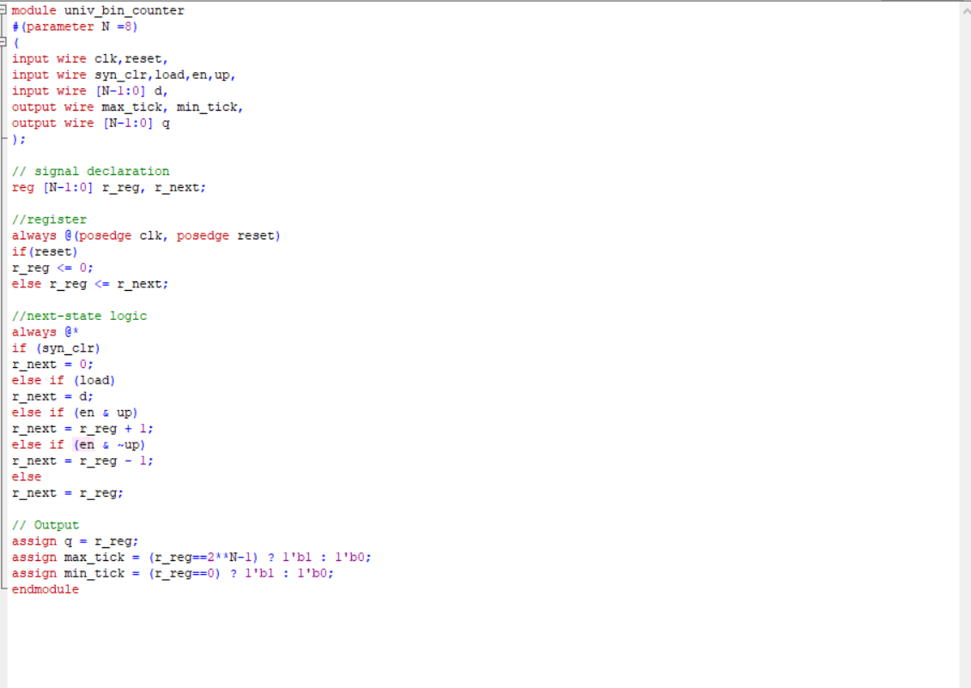

**Testbench**

`timescale 1ns/10ps

module bin_counter_tb();

localparam T =20; //clock period

reg clk,reset;

reg syn_clr, load, en, up;

reg [2:0] d;

wire max_tick, min_tick;

wire [2:0] q;

univ_bin_counter #(.N(3)) uut

(.clk(clk),

.reset(reset),

.syn_clr(syn_clr),

.load(load),

.en(en),

.up(up),

.d(d),

.max_tick(max_tick),

.min_tick(min_tick),

.q(q));

always

begin

clk = 1'b1;

#(T/2);

clk = 1'b0;

#(T/2);

end

initial

begin

reset = 1'b1;

#(T/2);

reset = 1'b0;

end

//Other stimulus

initial

begin

// === initial input ===

syn_clr = 1'b0;

load = 1'b0;

en =1'b0;

up = 1'b1;

d = 3'b000;

@(negedge reset);

@(negedge clk);

load = 1'b1;

d = 3'b011;

@(negedge clk);

load = 1'b0;

repeat (2) @(negedge clk);

// === Test syn_clr ====

syn_clr = 1'b1;

@(negedge clk);

syn_clr = 1'b0;

// == Test up counter and pause ==

en = 1'b1;

up = 1'b1;

repeat(10) @(negedge clk);

en =1'b0;

repeat(2) @(negedge clk);

en = 1'b1;

repeat(2) @(negedge clk);

// === test down counter ===

up = 1'b0;

repeat(10) @(negedge clk);

// === wait statement ===

// continue till q = 2

wait (q ==2);

@(negedge clk);univ_bin_counter #(.N(3)) uut

(.clk(clk),

.reset(reset),

.syn_clr(syn_clr),

.load(load),

.en(en),

.up(up),

.d(d),

.max_tick(max_tick),

.min_tick(min_tick),

.q(q));

always

begin

clk = 1'b1;

#(T/2);

clk = 1'b0;

#(T/2);

end

initial

begin

reset = 1'b1;

#(T/2);

reset = 1'b0;

end

//Other stimulus

initial

begin

// === initial input ===

syn_clr = 1'b0;

load = 1'b0;

en =1'b0;

up = 1'b1;

d = 3'b000;

@(negedge reset);

@(negedge clk);

load = 1'b1;

d = 3'b011;

@(negedge clk);

load = 1'b0;

repeat (2) @(negedge clk);

// === Test syn_clr ====

syn_clr = 1'b1;

@(negedge clk);

syn_clr = 1'b0;

// == Test up counter and pause ==

en = 1'b1;

up = 1'b1;

repeat(10) @(negedge clk);

en =1'b0;

repeat(2) @(negedge clk);

en = 1'b1;

repeat(2) @(negedge clk);

// === test down counter ===

up = 1'b0;

repeat(10) @(negedge clk);

// === wait statement ===

up = 1'b1;

// continue until min_tick becomes 1

@(negedge clk);

wait(min_tick);

@(negedge clk);

up = 1'b0;

// === absolute delay ===

#(4*T);

en = 1'b0;

#(4*T);

$stop;

end

initial

$monitor($time, " clk=%b reset=%b syn_clr=%b load=%b en=%b up=%b d=%b q=%b min_tick=%b max_tick=%b", clk, reset,syn_clr,load,en,up,d,q,min_tick,max_tick);

endmodule

**Wave\**

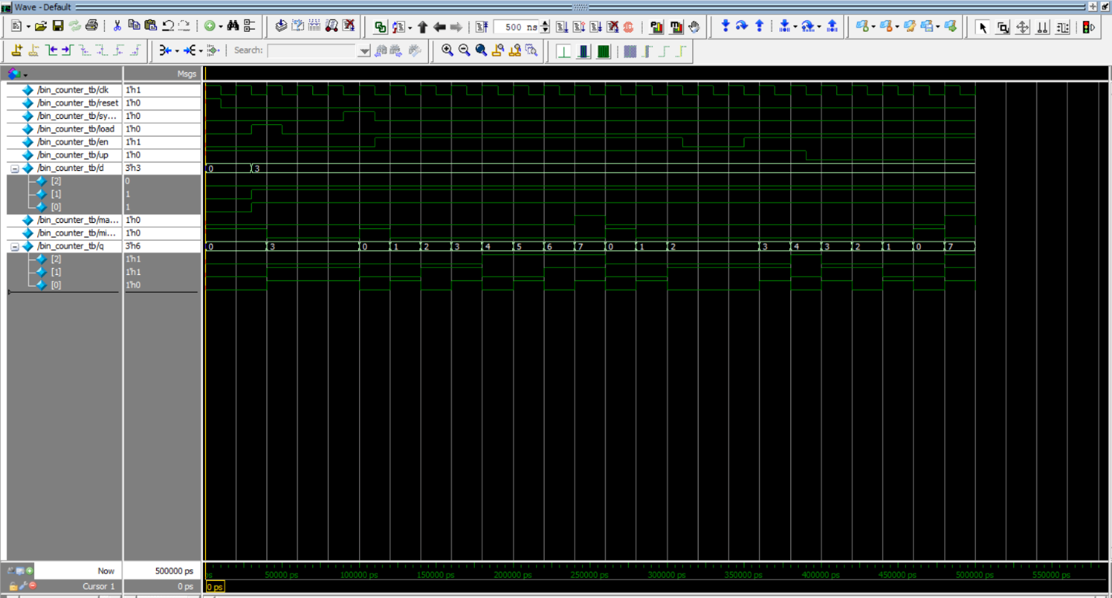

**Results**

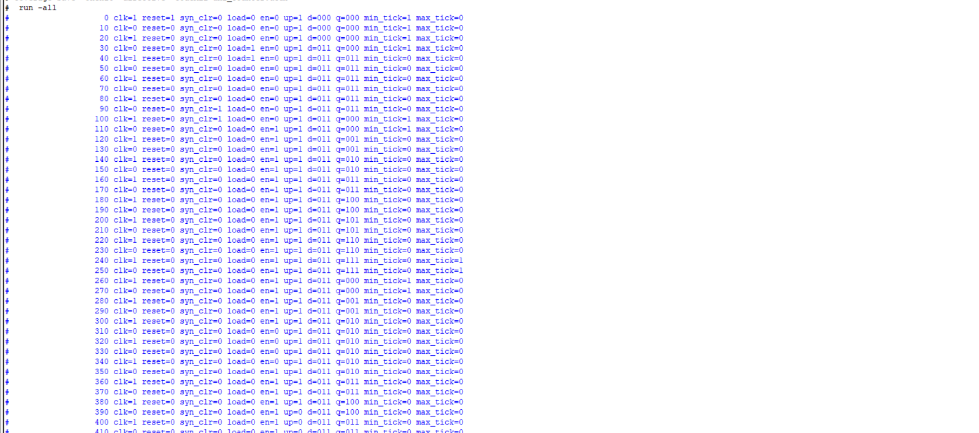

**Web coverage report**

